

Project Report

Fit4Life Web Portal

Contents

Case Study 3

1. Definition of the Problem 3
2. Requirement Analysis 4
3. Design Phase 5
4. Architecture of Website 6
5. Evaluation/Testing 7
6. Project Tracking and Monitoring Activities 7
7. Documentation Section 7
8. Source Code 7
9. User Guide 7

V 1.0 Aptech

# Case Study

The impact of Covid pandemic continuously disrupt daily routine of major population on the planet.

Addition of existing modern fast-paced lifestyles have led to further deteriorating health conditions.

People are now contracting ailments far earlier and spending more on hospitals and institutionalized healthcare. Heart diseases, back aches, inflamed joints, diabetes and so on are becoming too common and are being seen in young people.

To counter this, one should adopt a fitter and healthier lifestyle, that will have a good balance of nutrition, exercise, activity and rest.

### Proposed Solution

The proposed Website will be titled Fit4Life and should help individuals with fitness programs and diet plans. **Code Cadre** team has decided to design and build this Website which should have the functionality as following:

When a user visits the Web page of **Code Cadre**, they will be able to input some details such as age, BMI, pre-existing conditions (if available) and the webpage will provide dietary or physical activities recommendation based on the details given above.

# Definition of the Problem

After reading the project specifications, the developer states the scope of the project very briefly. This is referred to as the problem definition.

In the case of **Fit4Life** portal, queries website visitor can be one or all of the following:

* + 1. What is the dietary recommendation for them (the user)?
    2. What is the most suitable workout plan for them (the user)?
    3. Will the recommendation account for each individual due to body differences?
    4. Will the users be able to contact the company whose gave those recommendation?
    5. Will other companies be able to contact **Code Cadre** after visiting the site to display their resources on the **Code Cadre** portal?
    6. Will the users have access to other resources to reinforce their decision on following recommendations?

After consulting several IT companies and considering the budget constraints, **Code Cadre** teamhas decided to launch the Web application as a Single Page Responsive Web application. Hence, the project will use HTML5, CSS3, JavaScript, Geolocation API, Web Storage, AngularJS, and Bootstrap 3.3 libraries from getbootstrap.com, jQuery plugins or other HTML editors. Also, the site will be tested on popular browsers and mobile emulator software.

# Requirement Analysis

This phase consists of following:

### Webpage visitor will be able to type their name in welcome message, they will also be able to input their age and BMI from different choice of ranges.

### The system will display user name throughout their browsing session. The webpage will also display recommendation of dietary & workout plan base on age and BMI range given by user.

### Resource page displaying various news, articles and videos for user to reference and improve fitness

A number of non-functional requirements are in place, in the **Fit4Life** project, the system would be:

* Safe to use: The system should not result in any malicious downloads or unnecessary file downloads.
* Accessible: The system should have clear and legible fonts, user interface elements and navigation elements.
* Compatibility: The system should be compatible with latest browsers
* User – friendly: The system should be easy to navigate with clear menus and other elements and easy to understand

### Hardware Requirements:

* Intel Core i3/i5 Processor or higher
* 8 GB RAM or higher
* Color SVGA
* 500 GB Hard Disk space
* Mouse & Keyboard

### Software Requirements:

### Frontend: HTML5, CSS3, Bootstrap, JavaScript, jQuery, AngularJS,

### Angular9 (optional), XML

### Data Store: JSON files or TXT files

V 1.0 Aptech Ltd

## Project Guide

* Frontend: HTML5, CSS3, Bootstrap, JavaScript,
* Data Store: JSON files or TXT files

### Scope of the work:

Depending on the decision taken by the management regarding the **TechnoSavvy** portal, following are the requirements based on which the Single Page Application (SPA) needs to be developed:

* A home page for **TechnoSavvy** portal that will further display menu options for Register/Login, Marketplace, About Us, and Contact Us.
* Register/Login will lead to appropriate pages where users can register themselves or login if already registered.
* The Marketplace menu when clicked will display a Web page with logos of various companies each of which will have a hyperlink. Clicking the hyperlink will lead to the company information and its ad rates.
* About Us and Contact Us should contain some relevant information.
* The user can view and visit the links of their favorite brands or companies.

# Design Phase



### Designing the GUI Standards

For the **TechnoSavvy** portal, multiple screens must be created and linked to each other. Each of these screens should have a consistent look with respect to appearance, and theme used. The font styles, color of the labels, design and appearance of the command buttons, the appearance of header and footer, and the design and size of controls, such as check boxes or text boxes should be consistent through all the forms.

In the case of **TechnoSavvy** portal, the modules could be for:

* + Registration
  + Login
  + Appointment

### Assigning and Monitoring Tasks

You are expected to fill the Task sheet as shown in the document ‘**SWD/Form No. 7**’ given in the

Documentation Section of this Project Template.

You should fill the final checklist in the document ‘**SWD/Form No. 8**’ given in the Documentation

Section of this Project Template.

V 1.0 Aptech Ltd

## Project Guide

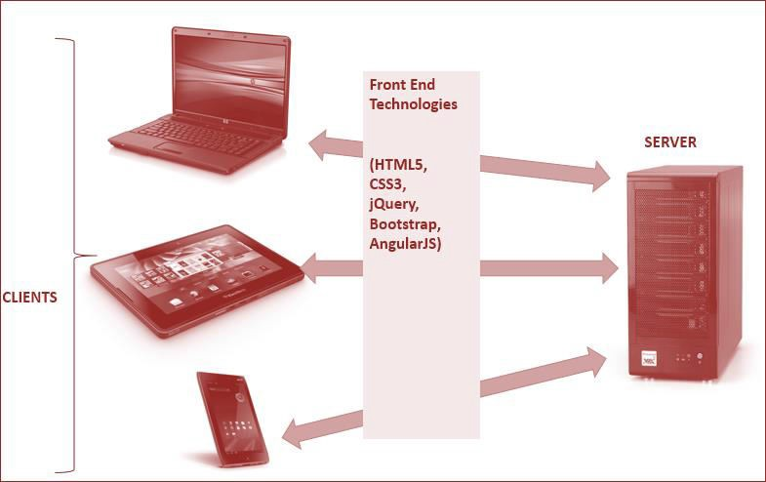

# Architecture of Website

Figure 1.1 displays the application architecture.

### Figure 1.1: Application Architecture

V 1.0 Aptech Ltd

## Project Guide



### Site Map

The sample site map illustrates the navigation flow of the objects on the Web portal.

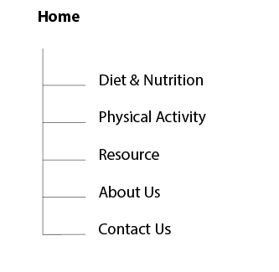

# Evaluation/Testing

Project has been tested for each page and each menu.

# Project Tracking and Monitoring Activities

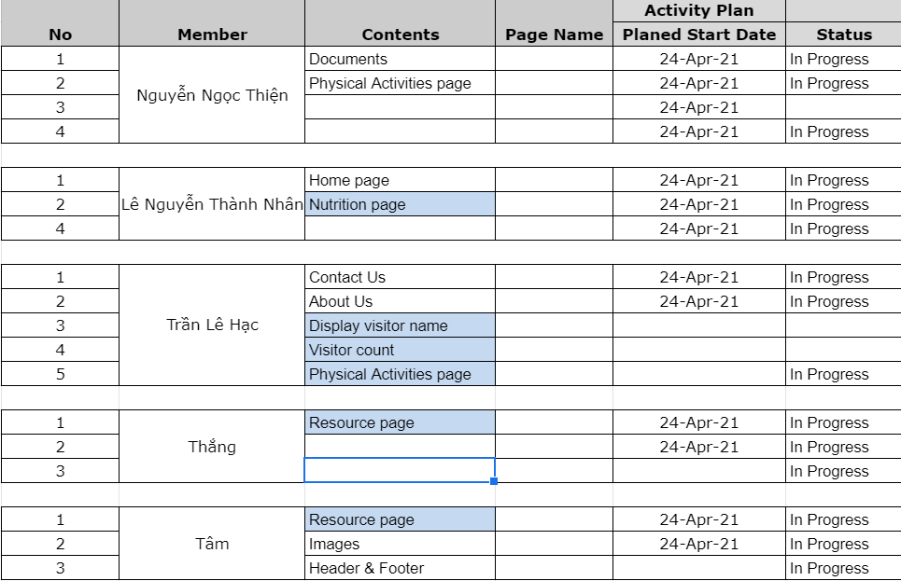.

# Documentation Section

<All filled up forms>

# Source Code

<Some of the sample Source code used in the project>

# User Guide

The Website will be hosted on a local Web server and will be tested on all latest and popular browsers such as IE, Opera, and Chrome. The requirements on the client machine include Pentium 4 or higher processor, 1 GB or higher RAM, and a compatible browser to view the Website.

*~~ End ~~*

V 1.0 Aptech Ltd